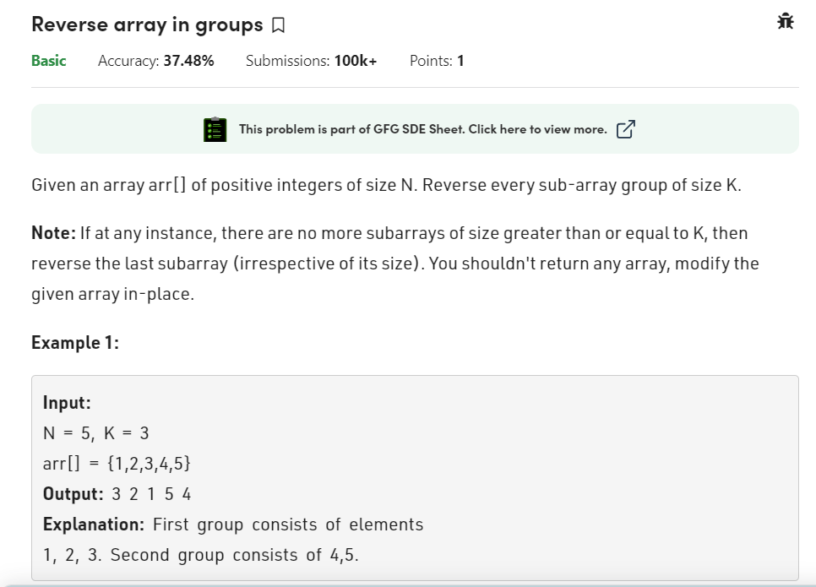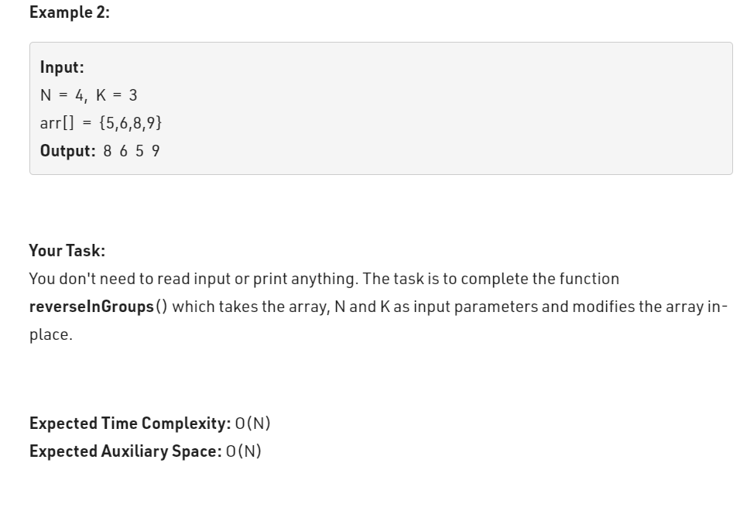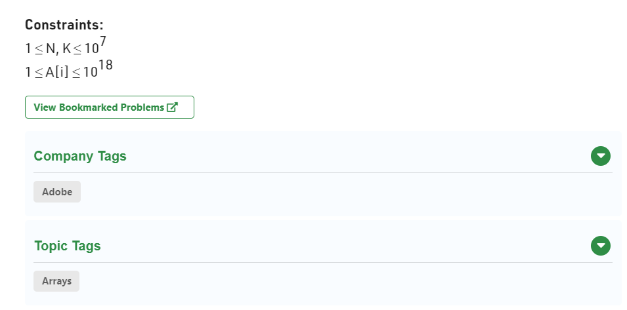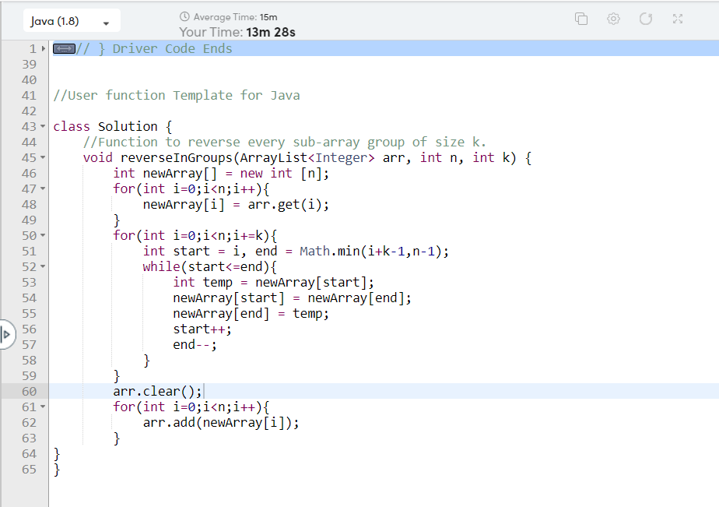

class Solution {

//Function to reverse every sub-array group of size k.

void reverseInGroups(ArrayList<Integer> arr, int n, int k) {

int newArray[] = new int [n];

for(int i=0;i<n;i++){

newArray[i] = arr.get(i);

}

for(int i=0;i<n;i+=k){

int start = i, end = Math.min(i+k-1,n-1);

while(start<=end){

int temp = newArray[start];

newArray[start] = newArray[end];

newArray[end] = temp;

start++;

end--;

}

}

arr.clear();

for(int i=0;i<n;i++){

arr.add(newArray[i]);

}

}

}